Diego Urbina

1219823

Introducción a la programación

Laboratorio 03

1. 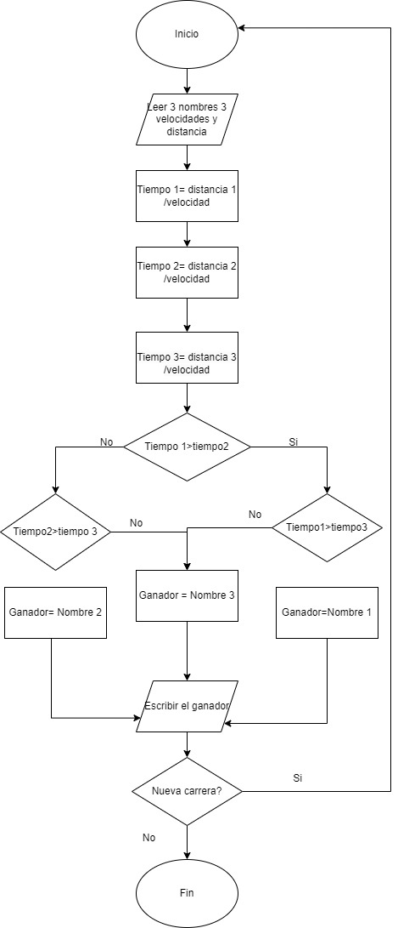

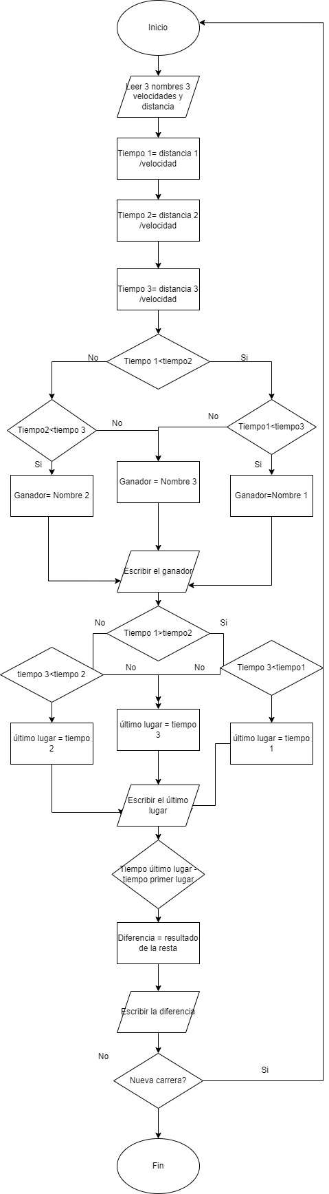

Tarea:

1. K

|  |  |  |  |  |  |
| --- | --- | --- | --- | --- | --- |
| Lenguaje | Declarativo | imperativo | Orientado a objetos | Intérprete | Compilador |
| C# |  |  |  |  | X |
| Java |  |  |  | X | X |
| Javascript |  |  |  | X |  |
| PHP |  |  |  | X |  |
| Perl |  |  | X | X |  |
| Python |  | X | X | X |  |
| C |  | X |  |  |  |
| Haskell |  |  |  | X |  |
| SQL | X |  |  |  |  |
| Ruby |  |  | X | X |  |
| Pascal |  | X |  |  | X |